CECS 529 Milestone 3

Group 8

Github link: <https://github.com/mxz0801/CECS529_Project1/tree/milestone3>

1. Bayesian classification
   1. The top 10 discriminating terms and their I(C,T) score.

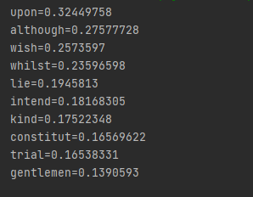

* 1. For paper_49, the Bayesian classification score

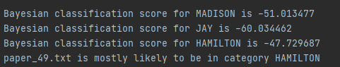

1. Rocchio classification
   1. For paper_52, the first 30 components

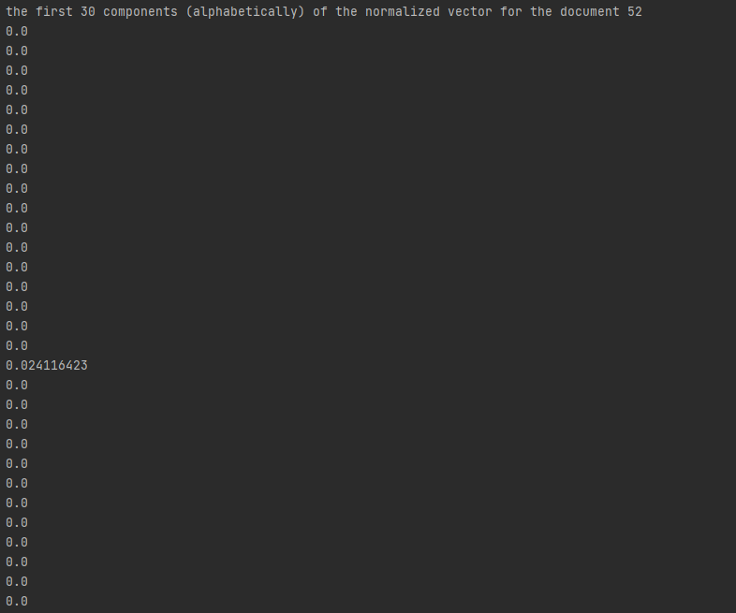

* 1. the distance between 3 class

